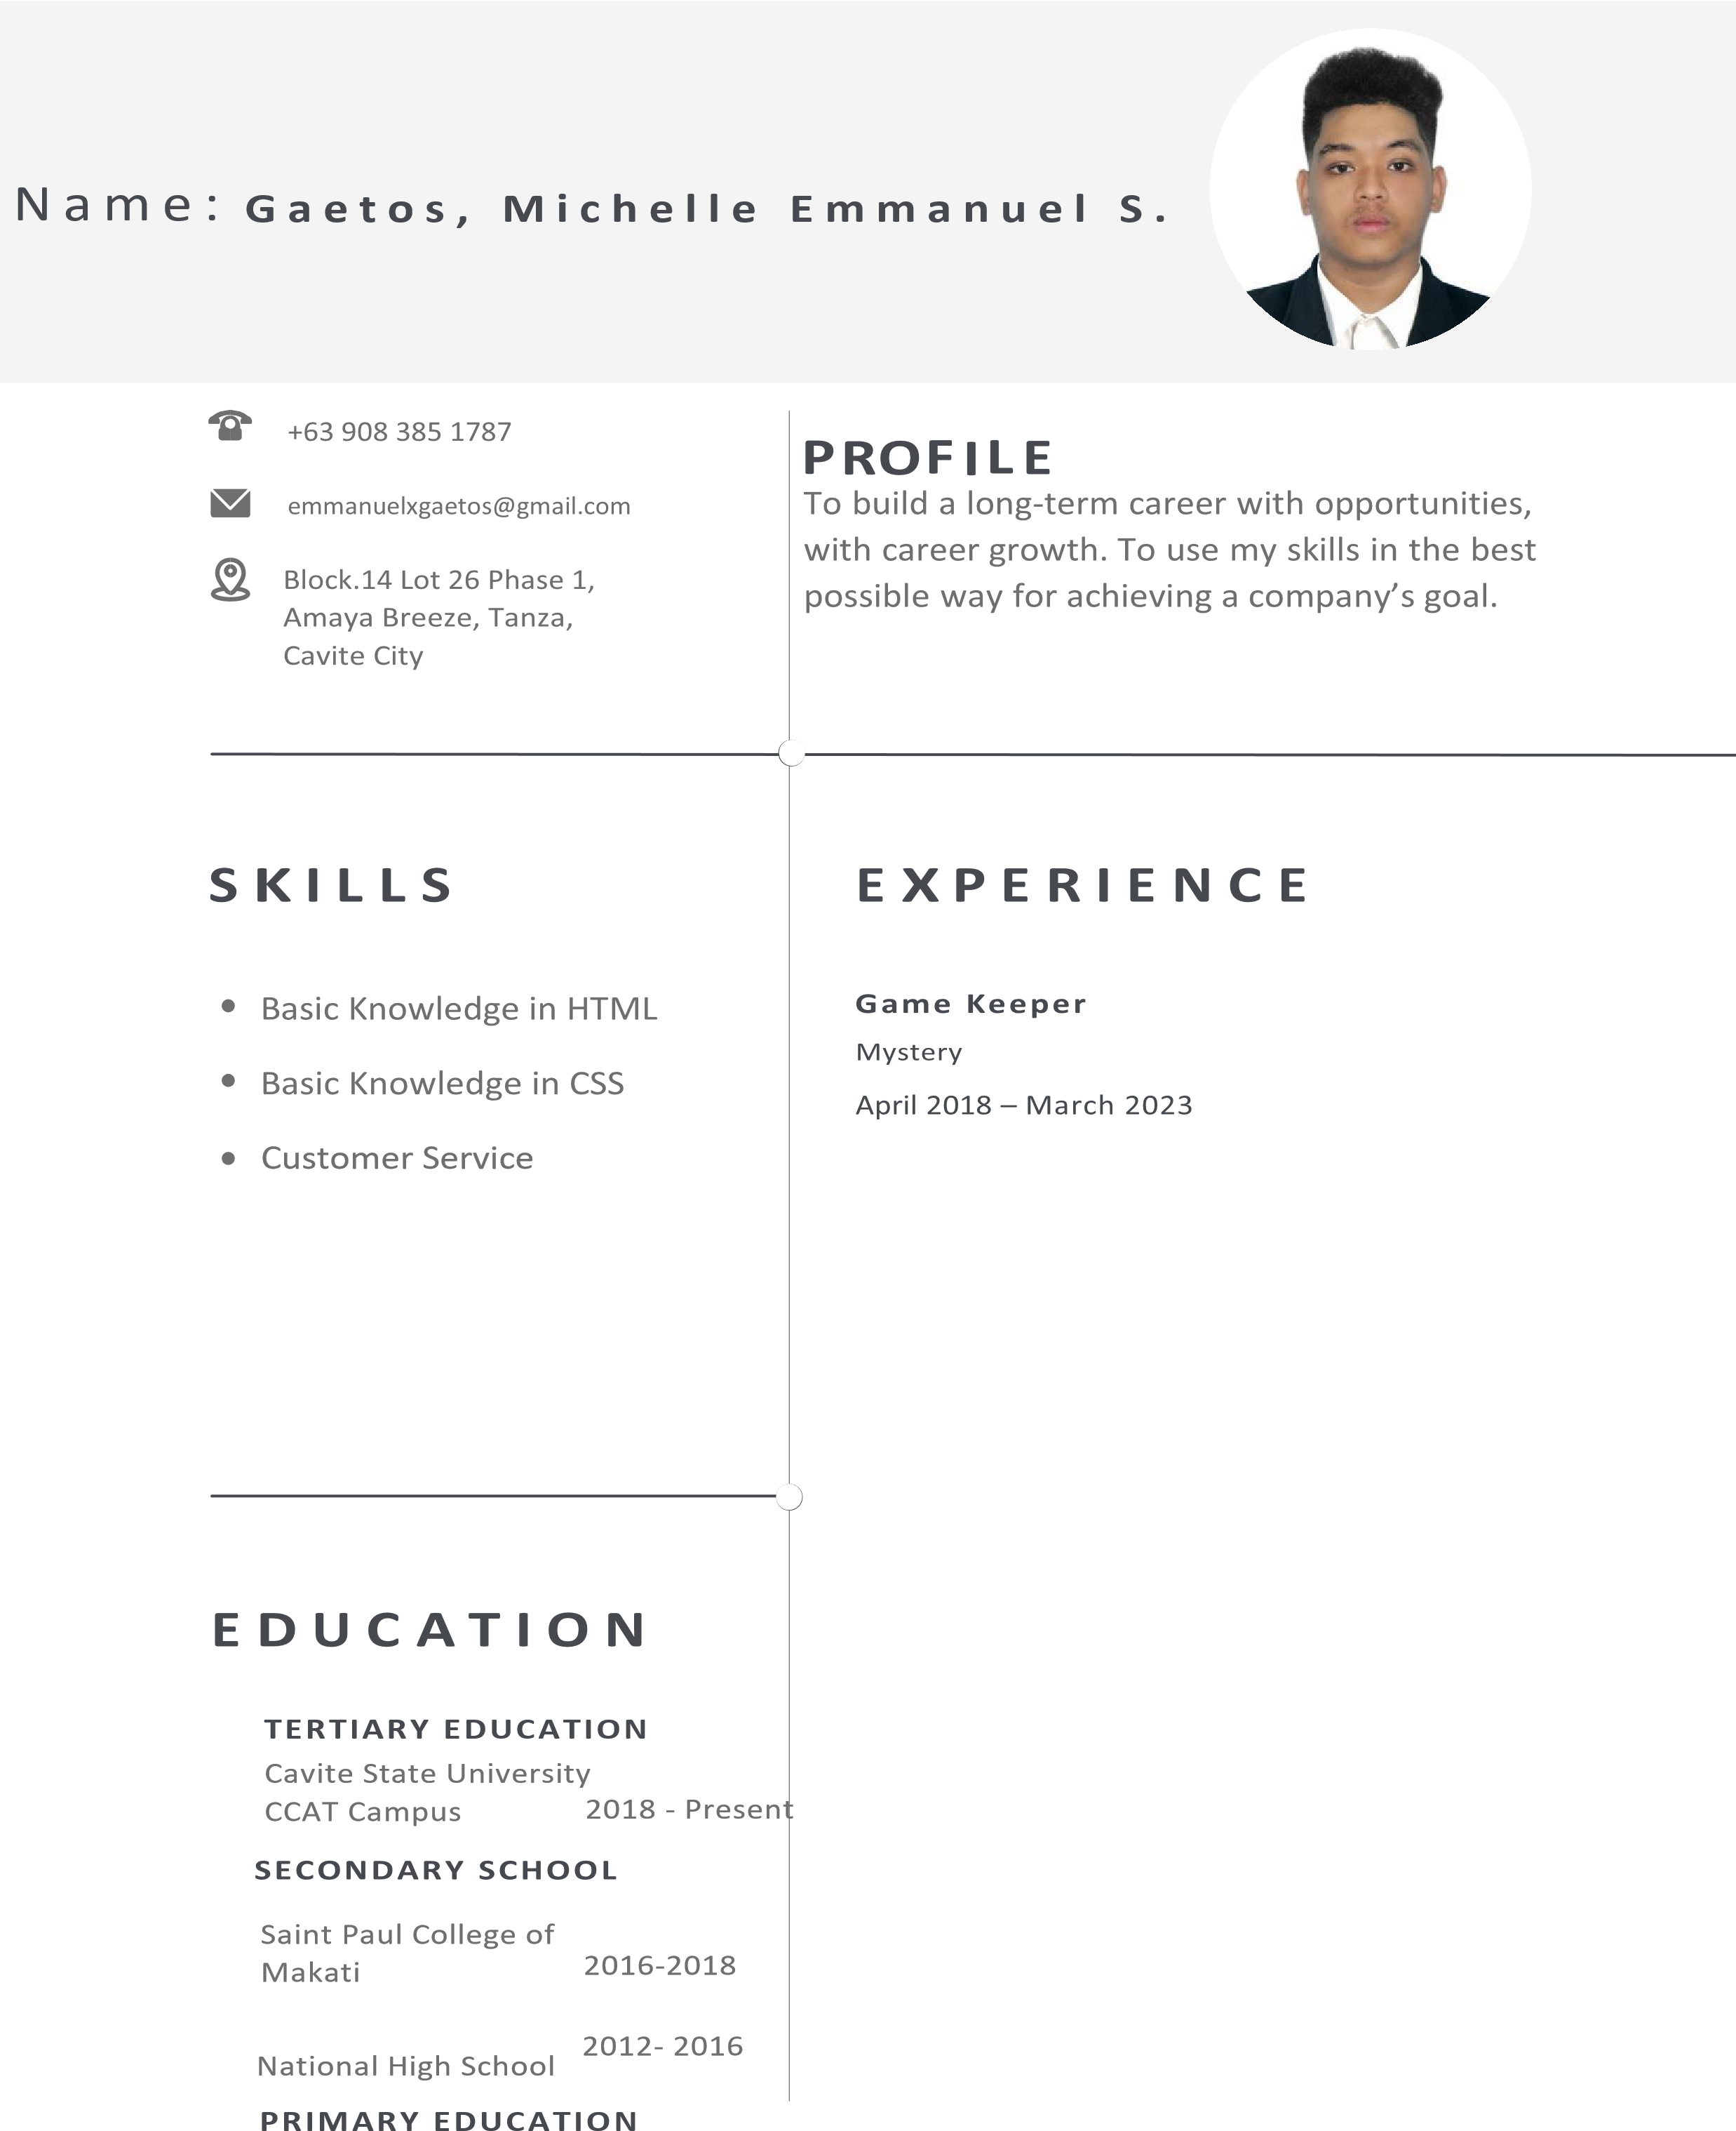General Pio Del Pilar

Makati Elementary School 2006- 2012

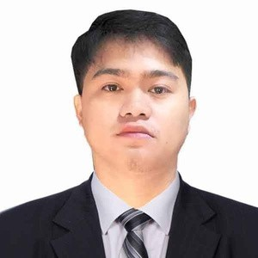JOHNUEL M. JAVIER

APPLICANT

Sitio Burol, Brgy Tejeros Convention Rosario, Cavite 0995-558-0873

[awelismjavier11@gmail.com](mailto:awelismjavier11@gmail.com)

**CAREER OVERVIEW**

Highly driven information technology student seeking an intern position in graphic designer where I can lend my knowledge of designing to help your organization improve profitability.

# EDUCATION

## Primary

Concepcion Pinagbakuran Elementary School 2005 - 2010 Sariaya, Quezon

## Secondary

Lutucan National High School 2012 - 2018

Sariaya, Quezon

## Tertiary

Bachelor of Science in Computer Science

Rosario, Cavite

Cavite State University CCAT Campus 2018 - 2023

# SKILLS

Basic knowledge in adobe Photoshop

Basic knowledge in video editing Basic knowledge in HTML, CSS and JAVASCRIPT

Basic knowledge in Microsoft Excel, Word and PowerPoint

# ACHIEVEMENT

NCII Passer

# REFERENCE

Mrs. Herlyn C. Maralan Public High School Teacher

Amaya School of Home Industries [herlyncostelo9@gmail.com](mailto:herlyncostelo9@gmail.com) 0926275192

**Affirmation Statement**

I hereby affirms that the information contained in the resume is true to the best of my knowledge and conscience.

Johnuel Javier (Applicant)

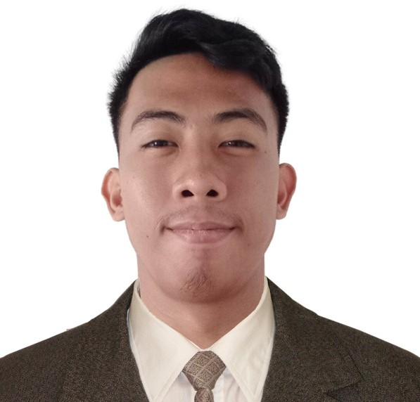REN RUSSEL E. LAVILLA

# APPLICANT

 B13 L9 PH2A Grand Riverside Subd. General Trias City, Cavite

 09759902764

[renlavilla12321@gmail.com](mailto:renlavilla12321@gmail.com)

# CAREER OVERVIEW

I manage secretarial duties like sorting and sending mail as a professional. To keep the office tidy and clean for guests or clients, I maintain an inventory of office supplies and place fresh orders as necessary.

**EDUCATION SKILLS**

### Tertiary

Bachelor of Science in Computer Science Rosario, Cavite

Cavite State University CCAT Campus 2018-2023

### Secondary

#### Senior High School:

Luis Y. Ferrer Junior Senior High School 2018-2016

South Square Village, Pasong kawayan 1, General Trias City, Cavite

#### Junior High School

Governor Ferrer Memorial High School 2016-2012

Pinagtipunan, General Trias City, Cavite

Verbal and written communication skills

Basic Knowledge in Graphic Designing (Adobe Photoshop) Basic Knowledge in Microsoft Excel, word, PowerPoint

## STRENGTH

Willingness to adapt new things and learn new knowledge

Hard working and obedient

## REFERENCE

Juliana Silva

CEO | Liceria & Co.

[hello@reallygreatsite.com](mailto:hello@reallygreatsite.com)

+123-456-7890

LESTER D. QUIJANO

# APPLICANT

 09502351005

 [quijanolester75@gmail.com](mailto:quijanolester75@gmail.com)

Bijia, Calibuyo, Tanza, Cavite

# CAREER OVERVIEW

Seeking a challenging position in a reputed organization where I can learn new skills, expand my knowledge, and leverage my learnings. To get an opportunity where I can make the best of my potential and contribute to the organization's growth.

**EDUCATION SKILLS**

### Tertiary

Bachelor of Science in Computer Science

Rosario, Cavite

Cavite State University CCAT Campus 2018 - 2023

### Secondary

Amaya School of home and industries

2012-2018

Sahud Ulan, Tanza Cavite

## Primary

* Flaviana F. Arayata Elementary School
* 2006- 2012
* Bagong Pook, Calibuyo, Tanza, Cavite
* Problem solving.
* Decision making.
* Concentration.
* Attention to detail.
* Teamwork.
* Able to follow instructions and
* production schedules.
* Able to act quickly when a problem arises

## REFERENCE

Flaviana F. Arayata Elementary School

2006- 2012

Bagong Pook, Calibuyo, Tanza, Cavite